*** npm install --save vuex

Step 1 : src er under e store->store.js create kora holo

*** store.js e jevabe shob normally korte hobe,

//store.js,

import Vue from "vue";

import Vuex from "vuex";

Vue.use(Vuex);

export const store = new Vuex.Store({

  state: {

    counter: 0,

  },

});

//now in main.js (importing store),

import Vue from "vue";

import App from "./App.vue";

import { store } from "./store/store.js";

new Vue({

  el: "#app",

  store,

  render: (h) => h(App),

});

***state e access normally vue3 er motoi, this.$store.state.counter;

***store.state er value computed e thakbe, eta ekta template example,

<template>

  <p>Counter is: {{ counter }}</p>

</template>

<script>

export default {

  computed: {

    counter() {

      return this.$store.state.counter;

    },

  },

};

</script>

***fix for using …map functions in vue v2, etuk fix na korle spread operator kaj korbe na vue v2 te,

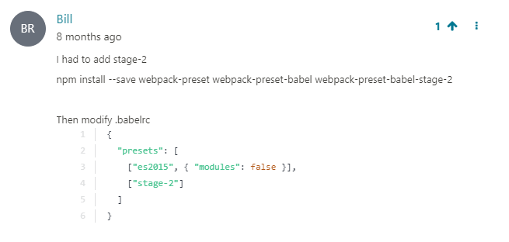

npm install --save webpack-preset webpack-preset-babel webpack-preset-babel-stage-2

//in babelrc,

{

  "presets": [["es2015", { "modules": false }], ["stage-2"]]

}

*** Two way binding in state management with commit(mutation) example,

<template>

  <div>

    <input type="text" :value="value" @input="updateValue" />

  </div>

</template>

<script>

export default {

  methods: {

    updateValue(value) {

      this.$store.commit("updateValue", event.target.value);

    },

  },

};

</script>

***Modules

Prothome ekta modules folder banate hobe ebong modules->counter.js banana holo, then counter.js e code jevabe likhte hobe,

const state = {

  counter: 0,

};

export default { //exporting

  state,

};

Then states er moddhe jevabe modules add korte hobe,

import Vue from "vue";

import Vuex from "vuex";

import counter from "./modules/counter.js";

Vue.use(Vuex);

export const store = new Vuex.Store({

  state: {},

  getters: {

    getCounter(state) {

      return state.counter.counter;

    },

  },

  mutations: {

    updateValue(state, value) {

      state.counter.counter = value;

    },

  },

  modules: {

    counter: counter, //modules

  },

});

**modules theke asha value gula object akare ashe , example { counter : 0 }, tai counter.counter lekha hoise

**** import * as actions from ‘./…..’; //eta hocche shob import korte pare

*****Namespace to avoid naming problems

import Vue from "vue";

import Vuex from "vuex";

import counter from "./modules/counter.js";

import * as types from "./types.js";

Vue.use(Vuex);

export const store = new Vuex.Store({

  state: {},

  getters: {

    getCounter(state) { //etake naming korte hobe ///////////////////////////

      return state.counter.counter;

    },

  },

  mutations: {

    updateValue(state, value) {

      state.counter.counter = value;

    },

  },

  modules: {

    counter: counter, //modules

  },

});

Step 1 : Prothome types.js name e ekta js file create kora holo,

export const GET_COUNTER = "counter/GET_COUNTER";

Step 2 :

evabe import kore nite hobe folder wise,

import * as types from "./types.js";

Then evabe getters er moto nam set kore dite hobe,

//from state.js,

import Vue from "vue";

import Vuex from "vuex";

import counter from "./modules/counter.js";

import * as types from "./types.js";

Vue.use(Vuex);

export const store = new Vuex.Store({

  state: {},

  getters: {

    [types.GET_COUNTER](state) {

      //name change kora hoise ///////////////////////////

      return state.counter.counter;

    },

  },

  mutations: {

    updateValue(state, value) {

      state.counter.counter = value;

    },

  },

  modules: {

    counter: counter, //modules

  },

});

//now in any .vue file jekhane namespace kora nam access kora lagbe,

<template>

  <p>Counter is: {{ getCounter }}</p>

</template>

<script>

import { mapGetters } from "vuex";

import * as types from "../types.js"; //importing type file

export default {

  computed: {

    ...mapGetters({ getCounter: types.GET_COUNTER }), //types folder structure  and GET_COUNTER holo set kora namespace

  },

};

</script>

types.GET_COUNTER holo namespace kore asha state e set kora name, muloto evabei kore name spacing & getCounter e object use kora hoise karon getCounter ke as a property hishabe use korar jonno & types.GET_COUNTER hocche namespace kora notun name.

****** import * as something mane shob import hoye ashbe, onno vue file theke export default kora lagbe na cause import * means shob e import kora hoise.